**Course**: MIS 342

**Task #6**: Design

**Due Date:** May 17, 2015 (by 6 PM)

**Project:**The Con Notification System

**Project sponsors**

Jason Watt(CTO)

Gil Cnann(CEO)

**Group 4 Members** **Professor Name**

Fidele Donadje Dr. Samir Shah, PMP, CSM

Calvin Speight

Feng Lin

Daniel Adams

Ashiya Patel

Table of contents

I-Hardware and software specifications……………………………………..1

II-User Interface Design

1-Layout…………………………………………………………….2

2-Content awareness……………………………………………...2

3-Aesthetics………………………………………………….….….3

4-Usage level……………………………………………..………..3

5-Consistency……………………………………………………...3

6-Minimize user effort………………………………………….…..3

7-Special Issues of Touch Screen Design………………………..4

8-Description of Access Layout…………………………………...4

III-Appendices

A-Discord PC User Interface……………………………….……..5

B-Discord Mobile User Interface………………………….……....6

**I-Hardware and software specifications**

|  |  |  |  |
| --- | --- | --- | --- |
|  | **Standard Client** | **Standard Chat Server** | **Standard Database Server** |
| **Operating System** | * Windows 8 * Android 4 * IOS 6-7.1 | Windows 7 Pro | Windows 7 pro |
| **Special software** | Discord | Discord Server | * Microsoft Access * Microsoft Word |
| **Hardware** | * 512 MB RAM * 1 Ghz processor * 32 GB Storage   Iphone 4 or higher | * Intel Core i5-4430 (3.0GHz - 3.2GHz) * 1TB hard drive * 2GB Ram | * 2TB hard drive * Intel Core i5-4430 (3.0GHz - 3.2GHz) * 4GB RAM |
| **Network** | 4G lte or Wifi | Dual 100Mbps Ethernet | Dual 100Mbps Ethernet |

**II-User Interface Design**

**1-Layout**

In looking at the layout of Discord we need to examine the areas on the screen and how the interfaces is applied to them. Discord seems to be following a somewhat standard layout. Discord uses the top of their standard area to for navigating to some of the features in the software has to offer. While on the left side, Discord has created a layout that allows users to navigates its various channels that the user is able to used to control the inputs and outputs which are widely shown in the middle. Overall, Discord does a good job in presenting the proper layout to allow its users to navigate successfully throughout its interface. While keeping a simple straightforward method of how to use the software.

**2-Content awareness**

Discord’s context awareness is not only clear, but it is consistent. When looking at the different channels to communicate with, the information is clear and easy to comprehend. As users navigate between the different channels not only does the individual channel that they are on light up in the list of channels, but the channel name is also displayed across the top for all users to quickly identify what channel they are located in. As you navigate to the direct message section information about who you are would like to message all available people are clearly displayed. Discord again is successfully able to clearly display their content information for people to easily access and understand where they are and where they would like to go.

**3-Aesthetics**

In terms of aesthetics Discord is appealing for all users. In anticipating many users may not be as knowledgeable with this discord’s interface, Discord does a good job in keeping a lower density. This refers to the amount of space that is being used and what is being left as “white space”. They have a proper balance so that new users will not be turned off by any cluttered spaces. The font size seems to vary between three different sizes, but it blends well so as to not seem unnatural to the web page.Finally the colors that were selected have a clean pattern. They are not too bold so that they distract the users from the message or soft so that they do not blend everything together.

**4-Usage level**

Discord is used by many user groups from professionals to gamers. The creator of the group/channel is able to create a user id and a server name in ease to start the conversation in text or through voice by inviting users via a link to connect to the channel. The creator is able to control the invite by setting the expiration time for the invite and max use of the invitation link or sending someone a temporary membership. Users are also able to connect to the channel by downloading the app on their smartphone. The channel owner is able to assign the “Channel Name” and “Channel Topic” and instant invite members to the group/channel. Permission controls will allow the channel owner to grant permissions to other users that will manage the group and assign roles. In Discord, the owner is able to set notification and privacy settings to better control whom will be notified in different cases, allowing mobile push notifications and verify members before they can post messages on the channel/group. It also has the ability to ban members from the group.

**5-Consistency**

Users are able to predict what will happen next when they select an option via web or mobile app. The website and mobile app are both easy to use and very straightforward. For instance, If the user selects mute voice then the voice will be muted. The group/channel management team is able to go through the features of the web and navigate through in ease. The owner of the channel is able to grant permissions to the management team and assign roles. The time frame for someone in the management team to learn all the feature of Discord should be less than a day. There are support documentations on the web such as FAQs if they run into any issues and you can even tweet the support team via Twitter and get a response immediately. The web layout is consistent and in order, users and the management team is able to locate the features/settings easily.

**6-Minimize user effort**

Through this app, users weren’t able to minimize the sidebar. The side bar for many apps are very large, and not all the features offered, are necessary throughout an individual's use. Through customer feedback, this was the only significant and common user issue that was found with Discord. After having taken action to resolve this issue, users will now be able to multi-task while using this app and have a more pleasant experience. Besides this issue, the app tackles and minimizes the effort a user has when using this app. Discord allows the user to see what the their friends may be doing at the specific time, along with that it is a more simple format compared to other systems such as Skype and TS3. It is available to run in a browser so the user does not need to download it. Along with that if there is a server failure of any kind, such as bad weather conditions takes out the data center, Discord will automatically switch you to a new server with little to no downtown and no loss of data.

**7-Special Issues of Touch Screen Design**

Discord app does not have any special issues of touch screen design. The design for this app is pretty simple and straightforward. There are no specific formats of touch screen which stand out from any other app features.

**8-Description of Access Layout**

The access database portion of the system will require manual input from the operator. The operator will be able to use a form to answer several key questions about the incident, such as giving a description and noting any additional resources required to handle it. The form will be straightforward and easy to use, minimizing the amount of time needed to train staff in it’s use. The Event ID field will be the key identifier for the form, and will be locked from editing. This prevents employees from causing any errors in the system. The form will input data into a main table, which can then be used to further investigate the data and create reports with that data for review by senior staff members.

**III-Appendices**

**A-Discord PC User Interface**

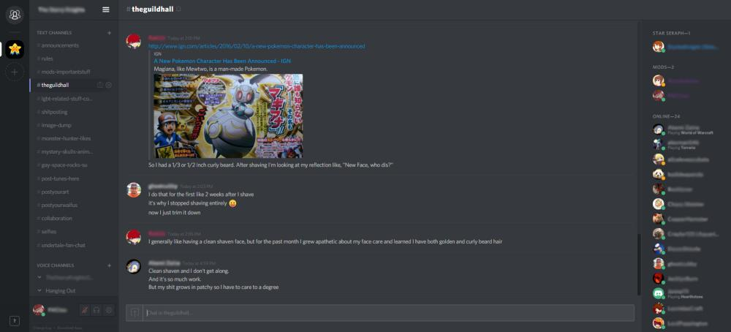

**B-Discord Mobile User Interface**

